**SSY130 – Hand in 2**

FIR Differentiator Design

Haitham Babbili

December 9, 2019

Student id: 19880803

Secret key: Drampa

Q1-

dt = 1; % s

f_s = 1/dt; % Hz

fcut = 0.05; % Hz

fstop = 0.1; % Hz

N = 60;

H_f = [0, fcut, fstop, f_s/2] /(f_s/2); % *pi [rad/sample]

H_a = [0, 1, 0, 0] .*H_f*pi *f_s; % filter amplitude

h_diff = firpm(N,H_f,H_a,'differentiator');

The code shows a low pass filter that performs approximate as differentiation for frequencies up to 0:05 Hz, while stop frequency equal to 0.1 Hz which reduce the influence of the noise.

As it described in Matlab document firpm use as $H_f$ to normalize frequency points, specified in the range between 0 and 1, where 1 corresponds to the Nyquist frequency $fs$/2.

In addition, in order to implement properly the differentiation in the pass-band region, we need amplitude vector H_a must correspond to the value *jj*, where *w* is the non-normalized frequency in rad/s. Also, the 'differentiator' argument will ensure the out of the filter to be constant phase of 90 °.

Q2-

The figure 1 & 2 below show the FIR filter and the Ideal FIR

Figure 1: FIR differentiator Filter impulse response (Amplitude Vs Sample)

Figure 2: plot the magnitude Vs normalize frequency

Q3-

Filtering the signal introduce shifting the signal in time domain which mean delay in time and rotation in frequency domain.

The function of *firpm* using the Parks-McClellan algorithm design a linear-phase FIR filter. Moreover, we are designing a filter of order N-1= 60. Since we are designing a linear phase Filter, its ideal impulse response is truncated to N=61 samples. The algorithm then introduces a delay of (N-1)/2=30 samples to make the filter causal. In time this is equivalent to (N-1)/2 $∆t$ = 30s.

Q4-

A low pass filter use for truncation of high frequency that cause a ripple at the edges of time domain.

Figure 4-1 shows the Euler and FIR filter include true and measured data.

Figure 4-2 shown the Euler and FIR filter after filtering and delay

compensation, the delay effect is totally removed.

At the end of the filter output very large oscillations occur due to the effect of convolution

v(n) = h(n)*s(n)

If h(n) has size H and s(n) has size S, then the convolution will result in H+S-1 elements. It follows, that the last S-1 elements are calculated by zero-padding s(n) in S-1 elements.

We can realize that the last element in S is very large and the zero-padding will artificially create a large position displacement and consequently a large velocity.

This is the reason why we usually discard this part of the resulted convoluted signal.

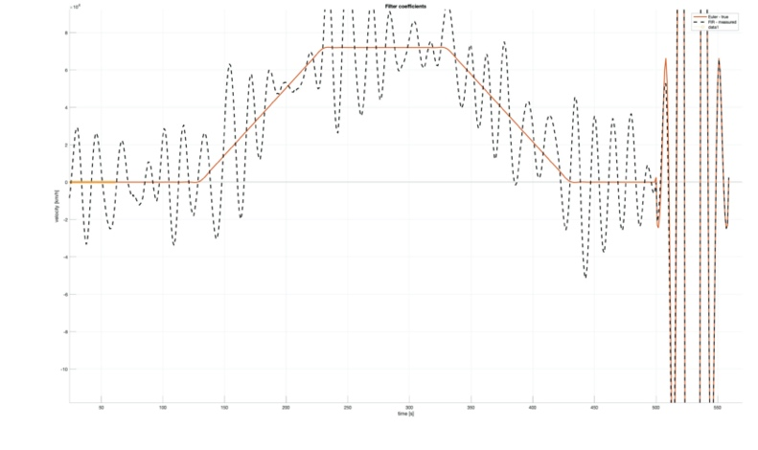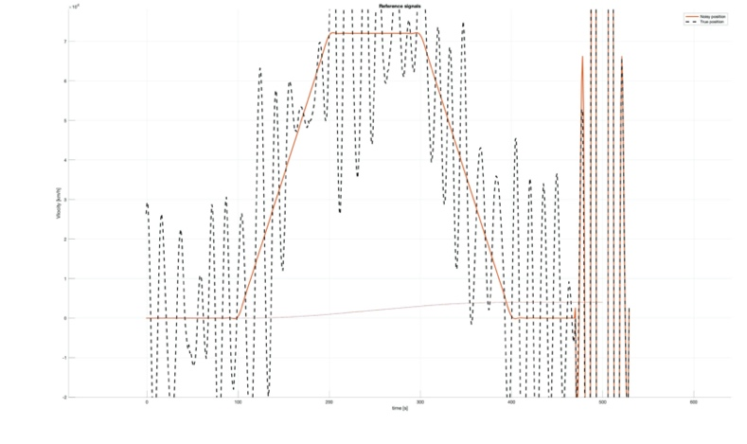

Figure 4-1 Measured velocity throw Euler and FIR filter. Figure 4-2 the velocity throw Euler and FIR filter after delay

Q5-

It’s clearly from the figure that the velocity dominated by the noise and the reasone for that is tacking the derivative for the signal that corrupted by noise followed by higher frequency will have a large amplified magnitude.

$$\frac{df(t)}{dt}⟶jω.F(ω)$$

In frequency domain derivative become multiplication. So that, high frequency noise component will be more amplified and dominate the output signal.

After filter the noise and tack the derivative, the noise amplification will decrease.

After all we can say the risk of reducing the amplitude will reduce the gain of the true signal that are close to this frequency. And so, each differentiator filter must be adjusted to the desired frequency range.



Q6-

If we want to calculate the maximum speed of the vehicle, we have to design our system in way to eliminate the noise and as we saw before that not possible.

Vehicle can achieve that by low accelerations profile, so we need to make our filter sharper by choosing the cutoff frequency equal to 0.01 and the stop frequency equal to 0.02 and the filter order equal to 300, so we get lower ripple magnitudes which means lower noise from the stop band. But that will increase the delay.

Since the time equals to 600-N/2=450s, the maximum speed of the vehicle in range 180 km/h.

